RECOMMENDED TOTAL STARTING DOSES BY AREA
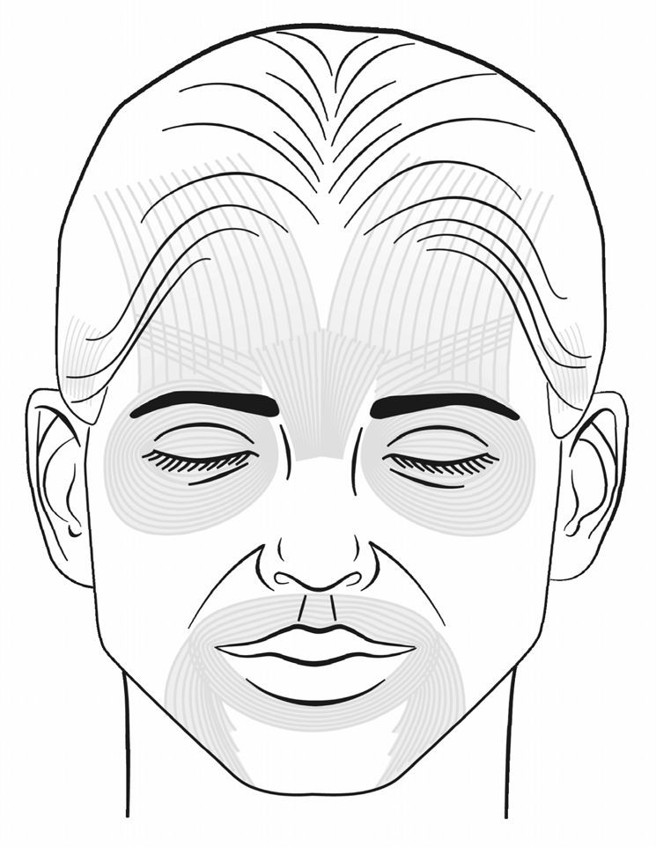Dosage the Same for Esthetic or Therapeutic Use

Frontalis Dose

female 4-14 u
male 10-20 u

Temporalis
Dose: 10 u

Glabellar dose
F: 20-25
M: 20-30

Crow’s feet
female: 4-12 u
male: 4-16 u
‘

Radial Lip Lines
female: 4-7 u
male: 5-8 u total dose for
7 injection points

Masseter
Starting dose: 10 u

©2013 Copyright American Academy of Facial Esthetics | LLC All Rights Reserved | No Duplication Allowed 16

