Myofascial Pain Examination

Patient Name: | Date: | Provider:
TMJ Examination
1. TMJ movement on opening | Right:  Left: | - normal  - normal | - limited  closed lock  locks open  - limited  closed lock  locks open
2. TMJ lateral pole tenderness | Right: Left: | - normal  - normal | - mild  moderate  severe  - mild  moderate  severe
3. TMJ sounds on right opening click: closing click:  crepitus: Is there pain associated with the TMJ sound?  Click eliminated on protrusive? |  | - none  - none  - none  - no  - no | - reproducible  non-reproducible  - reproducible  non-reproducible  - fine  coarse  - yes  - yes
4. TMJ sounds on left opening click: closing click:  crepitus: Is there pain associated with the TMJ sound?  Click eliminated on protrusive? |  | - none  - none  - none  - no  - no | - reproducible  non-reproducible  - reproducible  non-reproducible  - fine  coarse  - yes  - yes

Muscle Examination
- Mild | Right  - Moderate  Severe | - Refer | Trapezius | - Mild | - Moderate | Left  - Severe | - Refer
- Mild | - Moderate  Severe | - Refer | Sternocleidomastoid | - Mild  - Mild  - Mild  - Mild  - Mild  - Mild  - Mild | - Moderate  - Moderate  - Moderate  - Moderate  - Moderate  - Moderate  - Moderate | - Severe  - Severe  - Severe  - Severe  - Severe  - Severe  - Severe | - Refer  - Refer  - Refer  - Refer  - Refer  - Refer  - Refer
- Mild | - Moderate  Severe | - Refer | Splenius Capitus
- Mild | - Moderate  Severe | - Refer | Superficial Masseter
- Mild | - Moderate  Severe | - Refer | Deep Masseter
- Mild | - Moderate  Severe | - Refer | Anterior Temporalis
- Mild | - Moderate  Severe | - Refer | Middle Temporalis
- Mild | - Moderate  Severe | - Refer | Posterior Temporalis

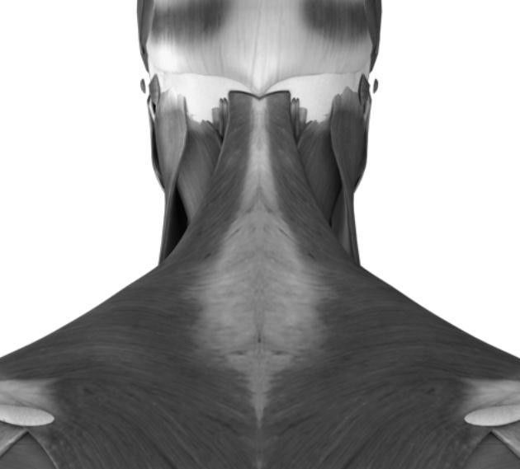
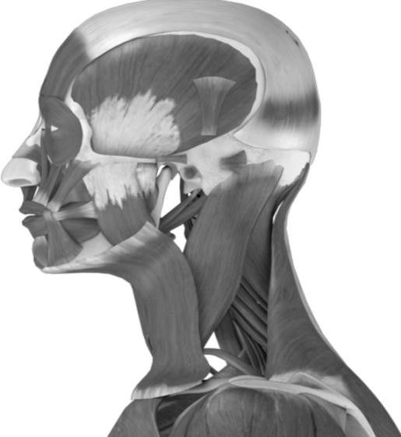
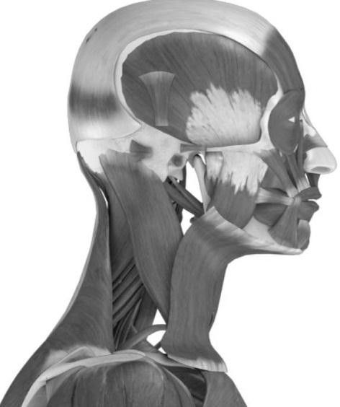

Mandibular Range of Motion
1. Maximum incisal pattern on opening |  | - Straight  Deflection to right  - Deflection to left  - Deviation to left  Deviation to right
2. Unassisted opening without pain |  |  | | | mm
3. Maximum unassisted opening (by patient) Normal opening 40-60mm | Pain? |  | | | mm
 |  | - no |  | - joint | - Rt | - Lt | - muscle | - Rt | - Lt
4. Maximum assisted opening (with stretch) Normal opening 40-60mm | Pain? |  | | | mm
 |  | - no |  | - joint | - Rt | - Lt | - muscle | - Rt | - Lt
5. Right lateral excursion Normal excursion 10mm | Pain? |  | | | mm
 |  | - no |  | - joint | - Rt | - Lt | - muscle | - Rt | - Lt
6. Left lateral excursion Normal excursion 10mm | Pain? |  | | | mm
 |  | - no |  | - joint | - Rt | - Lt | - muscle | - Rt | - Lt
7. Protrusion  Normal excursion 10mm | Pain? |  | | | mm
 |  | - no |  | - joint | - Rt | - Lt | - muscle | - Rt | - Lt

Recommendations
Injections | - Botox Injections | - Nerve Block | - TMJ
Splint/Orthotic | - Type:
Self-Care | - Exercise Diary | - Oral Habits | - Pain
Medication | - Anti-Inflammatory Chloride Spray | - Muscle Relaxant | - Ethyl
Imaging | - Refer  Other:
Physical Therapy | - Refer to evaluate and treat  - Exercise:  Postural  6 by 6  Stretching  Relaxation
Behavioral Health | - Refer  Other:
TMJ Surgery | - Refer  Other:

Diagnosis (check all that apply)  R L Joint Disorders  -  TMJ Ankylosis and Adhesions M26.61  -  TMJ Arthralgia and Inflammation M26.62  -  TMJ Disc Disorder (reducing) M26.63  -  TMJ Disc Disorder (non-reducing) M26.63  -  TMJ Dislocated Jaw, closed lock S03.0XXA  -  TMJ Dislocated Jaw, open lock S03.0XXA  -  TMJ Osteoarthritis, local & 1° M19.91  -  TMJ Rheumatoid Arthritis M15.0  -  TMJ Traumatic Arthropathy M12.58  -  TMJ Strain/Sprain from Overuse S03.4XXA  -  TMJ Implant Failure M26.61  -  TMJ Tumor Benign D16.5  -  TMJ Tumor Other: |  | Muscle Disorders  - Muscle Spasm M62.40  - Myofascial Pain: Masticatory M60.9  - Myofascial Pain: Cervical M60.9  - Fibromyalgia/Chronic fatigue M79.7  Headache  - Migraine with Aura G43.109  - Migraine without Aura G43.009  - Cluster Headache G43.811  - Tension-Type Headache G44.209  - Rebound/Transformed R51 | Neuropathic  - Trigeminal Neuralgia G50.0  - Atypical Face Pain G50.1  - Glossodynia/ Burning Mouth K14.6  Other  - Orofacial Dyskinesia G24.4  - Bruxism/Teeth Grinding F45.8  - Psychological Factors F54  - Anomalies of Jaw Size M26.00  - List:
Referral
Provider: | Date:

