Diagnosis and Treatment Plan
Patient Name: Date:
Treating Provider Name:
Health History Completed? Yes □ No □ Date: Provider Initial:
Dental / Head and Neck Examination Completed? Yes □ No □ Date: Provider Initial:
Informed Consent Completed? Yes □ No □

- M26.00 Anomalies of jaw size
- M26.12 Maxillary asymmetry
- K08.109 Loss of teeth
- M26.9 Dentofacial anomalies
- K13.0 Diseases of lips
- S01.551 Cheek/Lip biting
- K08.419 Loss of teeth trauma
- M26.12 Jaw asymmetry
- M26.50 Dentofacial abnormal funct
- Other
- Other
- Other

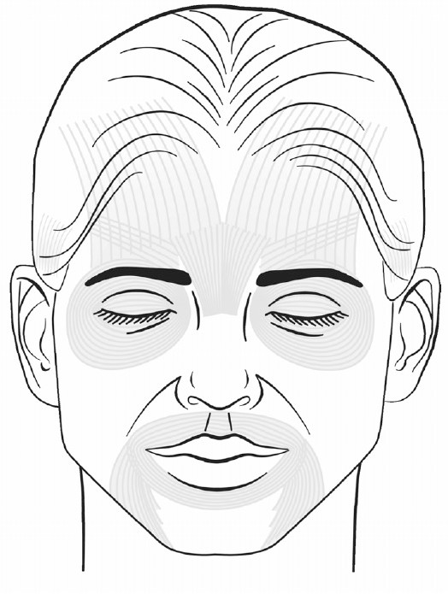
Areas Treated | Vials | Total Volume (mL)
Kybella

© American Academy of Facial Esthetics LLC, all rights reserved, no duplication allowed.

