Diagnosis and Treatment Plan
Patient Name: Date: Treating Doctor Name:
Health History Completed? Yes □ No □ Date: Doctor Initial:
Dental / Head and Neck Examination Completed? Yes □ No □ Date: Doctor Initial: Informed Consent Completed? Yes □ No □

- K03.0 Excessive attrition
- K03.81 Cracked tooth
- K06.0 Gingival recession
- M26.00 Anomalies of jaw size
- M26.12 Maxillary asymmetry
- K08.109 Loss of teeth
- M26.9 Dentofacial anomalies
- K13.0 Diseases of lips
- S01.551 Cheek/Lip biting
- K08.419 Loss of teeth trauma
- M26.12 Jaw asymmetry
- M26.50 Dentofacial abnormal funct
- Other
- Other
- Other

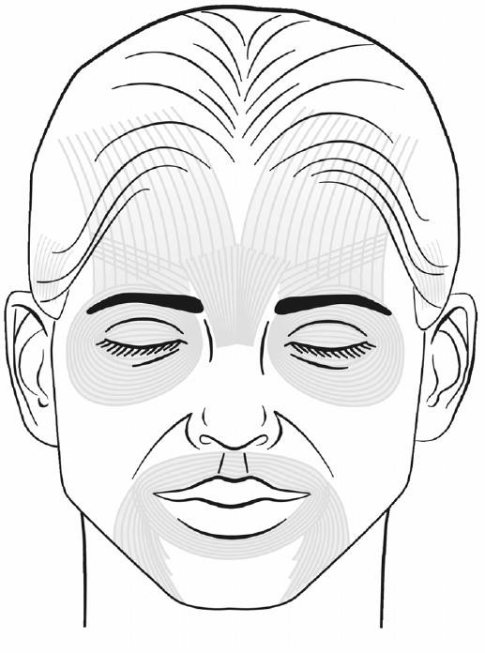
Muscle Filler Volume Used Used ml
(R) Nasolabial Fold
(L) Nasolabial Fold
(R) Marionette Line
(L) Marionette Line
Upper Lip
Lower Lip
(R) Oral Comm
(L) Oral Comm

Total volume used:

© American Academy of Facial Esthetics LLC, all rights reserved, no duplication allowed.

