Diagnosis and Treatment Plan
Patient Name: Date: Treating Doctor Name:
Health History Completed? Yes □ No □ Date: Doctor Initial:
Dental / Head and Neck Examination Completed? Yes □ No □ Date: Doctor Initial: Informed Consent Completed? Yes □ No □

- K03.0 Excessive attrition
- K03.81 Cracked tooth
- K06.0 Gingival recession
- M26.00 Anomalies of jaw size
- M26.11 Maxillary asymmetry
- M26.12 Jaw asymmetry
- M26.52 Orofacial dyskinesia
- M26.53 Limited range of motion
- M26.53 Deviation opening closing
- M26.50 Dentofacial abnormal fx
- K08.109 Loss of teeth
- M26.60 TMJ disorders
- M26.63 TMJ disc disorder (reducing/non-reducing)
- M26.69 TMJ sounds opening/closing jaw
- M26.9 Dentofacial anomalies
- K13.0 Diseases of lips
- K13.70 Cheek/Lip biting
- K08.419 Loss of teeth trauma
- G47.63 Sleep related bruxism
- M62.40 Muscle spasm
- G50.1 Atypical facial pain
- R25.0 Trismus
- M79.1 Myalgia
- M60.9 Myofascial pain
- M79.2 Neuralgia, neuritis, facial
- S03.4XXA Jaw sprain
- G44.209 Tension headache
- G43.109 Migraine with aura
- G43.009 Migraine without aura
- G43.811 Cluster headache
- R51 Headache
- F45.8 Bruxism
- G50.0 Trigeminal neuralgia
- Other

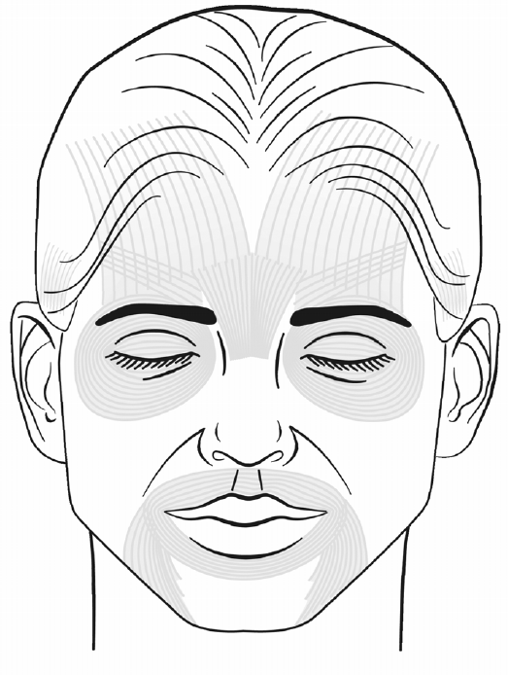
Muscle Dosage Syringe (in units) Volume
Frontalis
Glabella
(L) Orbicularis oculi
(R) Orbicularis oculi
Orbicularis Oris
(L) Temporalis
(R) Temporalis
(L) Masseter
(R) Masseter

Total units needed:

© American Academy of Facial Esthetics LLC, all rights reserved, no duplication allowed.

