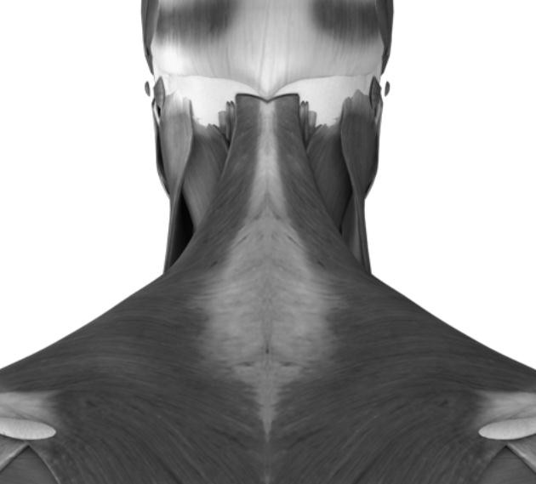
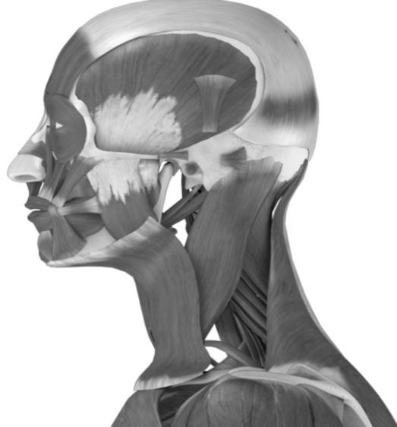
Myofascial Pain Examination

Patient Name: Date: Doctor:

TMJ Examination

1. TMJ movement on opening Right:  Left: |  normal  limited  closed lock  locks open   normal  limited  closed lock  locks open
2. TMJ lateral pole tenderness Right: Left: |  normal  mild  moderate  severe   normal  mild  moderate  severe
3. TMJ sounds on right opening click: closing click: crepitus:  Is there pain associated with the TMJ sound?  Click eliminated on protrusive? |  none  reproducible  non-reproducible   none  reproducible  non-reproducible   none  fine  coarse   no  yes   no  yes
4. TMJ sounds on left opening click: closing click: crepitus:  Is there pain associated with the TMJ sound?  Click eliminated on protrusive? |  none  reproducible  non-reproducible   none  reproducible  non-reproducible   none  fine  coarse   no  yes   no  yes

Muscle Examination

 Mild | Ri   Moderate | ght   Severe |  Refer | Trapezius |  Mild |  Moderate | Left   Severe |  Refer
 Mild |  Moderate |  Severe |  Refer | Sternocleidomastoid |  Mild |  Moderate |  Severe |  Refer
 Mild |  Moderate |  Severe |  Refer | Splenius Capitus |  Mild |  Moderate |  Severe |  Refer
 Mild |  Moderate |  Severe |  Refer | Superficial Masseter |  Mild |  Moderate |  Severe |  Refer
 Mild |  Moderate |  Severe |  Refer | Deep Masseter |  Mild |  Moderate |  Severe |  Refer
 Mild |  Moderate |  Severe |  Refer | Anterior Temporalis |  Mild |  Moderate |  Severe |  Refer
 Mild |  Moderate |  Severe |  Refer | Middle Temporalis |  Mild |  Moderate |  Severe |  Refer
 Mild |  Moderate |  Severe |  Refer | Posterior Temporalis |  Mild |  Moderate |  Severe |  Refer

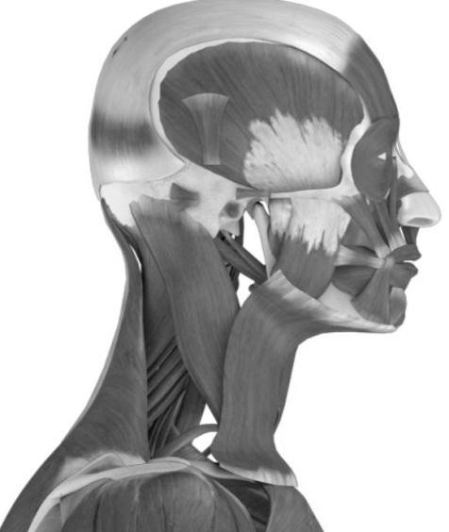

Mandibular Range of Motion
1. Maximum incisal pattern on opening |  Straight  Deflection to right   Deflection to left   Deviation to left  Deviation to right
2. Unassisted opening without pain |  | | | mm
3. Maximum unassisted opening (by patient) Normal opening 40-60mm  Pain? |  | | | mm
 |  no |  |  joint  Rt  Lt |  muscle  Rt  Lt
4. Maximum assisted opening (with stretch)  Normal opening 40-60mm Pain? |  | | | mm
 |  no |  |  joint  Rt  Lt |  muscle  Rt  Lt
5. Right lateral excursion  Normal excursion 10mm Pain? |  | | | mm
 |  no |  |  joint  Rt  Lt |  muscle  Rt  Lt
6. Left lateral excursion  Normal excursion 10mm Pain? |  | | | mm
 |  no |  |  joint  Rt  Lt |  muscle  Rt  Lt
7. Protrusion  Normal excursion 10mm Pain? |  | | | mm
 |  no |  |  joint  Rt  Lt |  muscle  Rt  Lt

Recommendations
Injections |  Botox  Nerve Block  TMJ Injections
Splint/Orthotic |  Type:
Self-Care |  Exercise  Oral Habits  Pain  Diary
Medication |  Anti-Inflammatory  Muscle Relaxant  Ethyl  Chloride Spray
Imaging |  Refer  Other:
Physical Therapy |  Refer to evaluate and treat   Exercise:  Postural  6 by 6  Stretching  Relaxation
Behavioral Health |  Refer  Other:
TMJ Surgery |  Refer  Other:

Diagnosis (check all that apply)  R L Joint Disorders    TMJ Ankylosis and Adhesions M26.61    TMJ Arthralgia and Inflammation M26.62    TMJ Disc Disorder (reducing) M26.63    TMJ Disc Disorder (non-reducing) M26.63    TMJ Dislocated Jaw, closed lock S03.0XXA    TMJ Dislocated Jaw, open lock S03.0XXA    TMJ Osteoarthritis, local & 1° M19.91    TMJ Rheumatoid Arthritis M15.0    TMJ Traumatic Arthropathy M12.58    TMJ Strain/Sprain from Overuse S03.4XXA    TMJ Implant Failure M26.61    TMJ Tumor Benign D16.5    TMJ Tumor Other: |  | Muscle Disorders   Muscle Spasm M62.40   Myofascial Pain: Masticatory M60.9   Myofascial Pain: Cervical M60.9   Fibromyalgia/Chronic fatigue M79.7  Headache   Migraine with Aura G43.109   Migraine without Aura G43.009   Cluster Headache G43.811   Tension-Type Headache G44.209   Rebound/Transformed R51 | Neuropathic   Trigeminal Neuralgia G50.0   Atypical Face Pain G50.1   Glossodynia/ Burning Mouth  K14.6  Other   Orofacial Dyskinesia G24.4   Bruxism/Teeth Grinding F45.8   Psychological Factors F54   Anomalies of Jaw Size M26.00   List:
Referral
Doctor: | Date:

